**Test performance of web hosting service guidelines for Staff**

**Effective: January 2024**

**Version: 1.1**

Note, this document is available in alternative formats upon request including electronic or audio format.

Table of Contents

[Table of Contents 2](#_Toc161784311)

[Policy Statement 3](#_Toc161784312)

[Overview 3](#_Toc161784313)

[What website performance test tools look for 3](#_Toc161784314)

[website performance test tools 4](#_Toc161784315)

[1. Google PageSpeed Insights 5](#_Toc161784316)

[2. GTmetrix 6](#_Toc161784317)

[3. Pingdom 7](#_Toc161784318)

[4. WebPageTest 8](#_Toc161784319)

[5. WAVE Web Accessibility Evaluation Tool 9](#_Toc161784320)

[6. SEO Site Checkup 10](#_Toc161784321)

[7. Uptrends 11](#_Toc161784322)

[Summary 12](#_Toc161784323)

[Related polices and other relevant documents 12](#_Toc161784324)

[Related legislation 12](#_Toc161784325)

[Review Date 12](#_Toc161784326)

[Contact Information 12](#_Toc161784327)

[Revision History 12](#_Toc161784328)

Policy Statement

This Policy provides a set of guidelines to ensure consistency of reporting and monitoring of website traffic and SEO practices. Consistency is absolutely a prerequisite for maximising maintainability and reporting of website traffic. All users of Organisation IT services are required to comply with the principles outlined in this policy.

Overview

With today’s fast internet speeds, people expect content to load quickly and the content on your website is no exception.

How fast your website loads and the experience someone has browsing through it matters more than you think. In fact, conversion rates on a website [drop an average of 4.42%](https://blog.hubspot.com/marketing/page-load-time-conversion-rates) for each additional second it takes to load after the first five seconds.

Factors such as hosting speeds, the number of JavaScript elements a website has, and responsiveness all affect the performance of your website.

If you’re also focused on driving traffic to your website via SEO, [website performance](https://webflow.com/blog/measure-website-performance) is a crucial part to get right. Google rewards websites that provide a great user experience. If your website is slow, inaccessible, or is filled with bloated code, you’re going to have a hard time ranking high in search engine results.

Luckily, there are a handful of website performance testing tools available to help you do an audit of your site and identify what needs to be fixed.

What website performance test tools look for

Every website performance testing tool is built with different ways of monitoring a website. Each tool you use will show you different results.

Some tools are great for checking loading speeds, others are useful for finding web accessibility errors, and some are ideal for monitoring SEO best practices.

All of the tools on this list will let you track things like:

* Web Core Vitals and Lighthouse scores
* Page loading times
* What resources take the longest to load
* Website responsiveness and accessibility
* SEO errors
* Images that need to be optimized
* JavaScript and CSS issues

Make sure to run your website through multiple tools to get a comprehensive overview of how your website performs on different devices, locations, and browsers.

website performance test tools

Every website performance testing tool is built with different ways of monitoring a website. Each tool you use will show you different results.

Some tools are great for checking loading speeds, others are useful for finding web accessibility errors, and some are ideal for monitoring SEO best practices.

All of the tools on this list will let you track things like:

* Web Core Vitals and Lighthouse scores
* Page loading times
* What resources take the longest to load
* Website responsiveness and accessibility
* SEO errors
* Images that need to be optimized
* JavaScript and CSS issues

In the list below, you’ll also be able to see what each tool is best for. Make sure to run your website through multiple tools to get a comprehensive overview of how your website performs on different devices, locations, and browsers.

1. [Google PageSpeed Insights](https://pagespeed.web.dev/)

**Best for:** Checking Google’s Web Core Vitals

‍

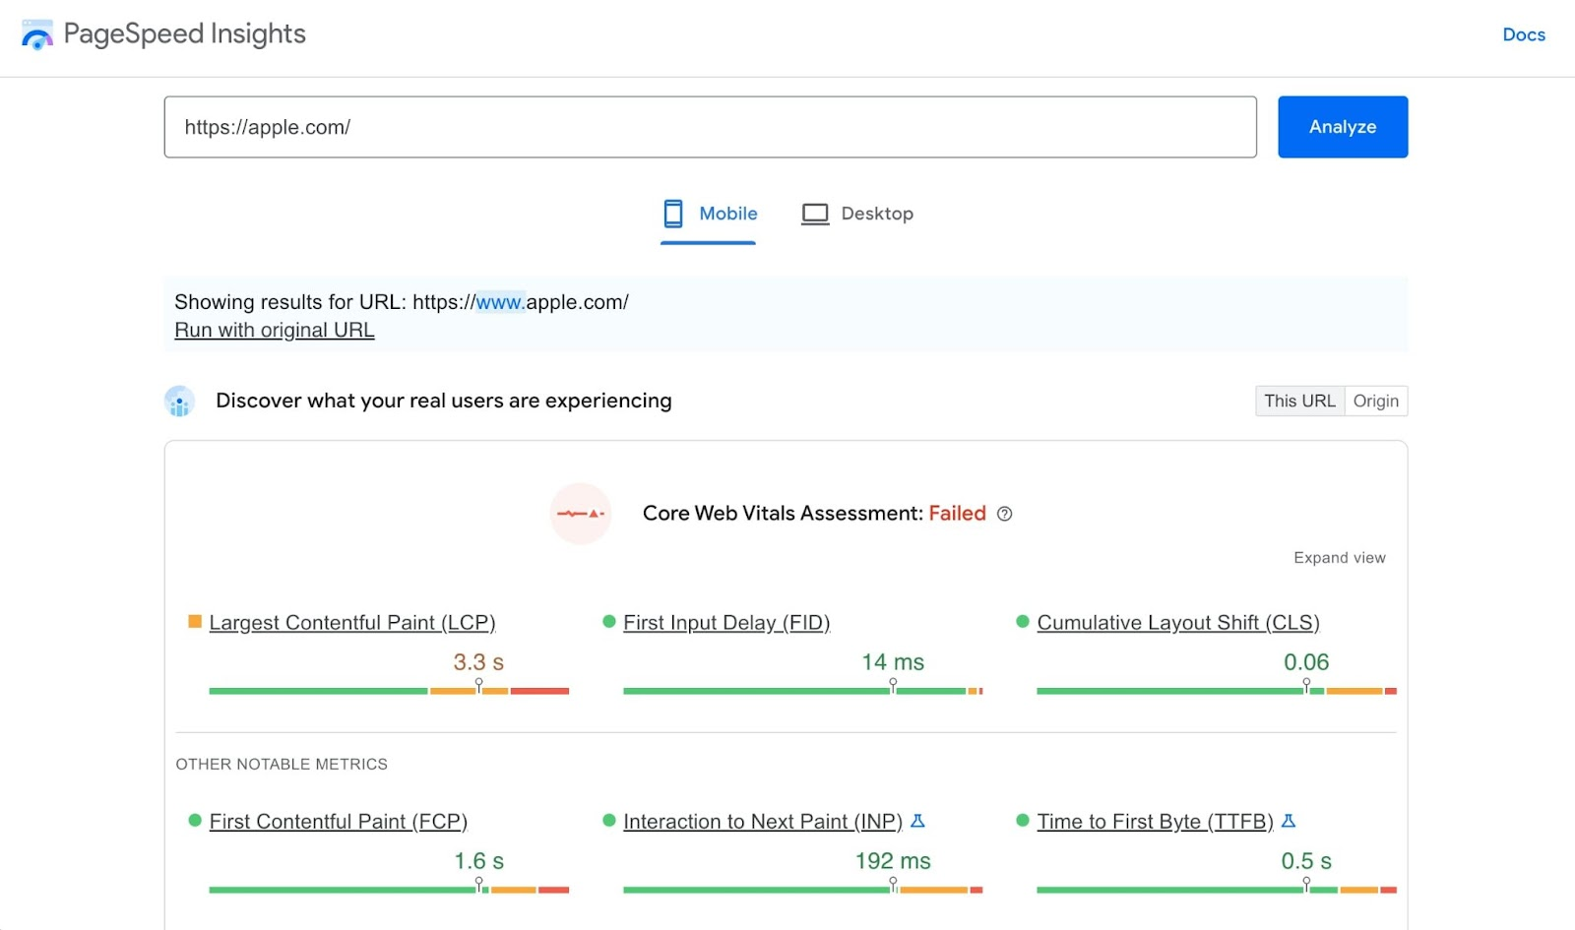

‍

First on our list is Google’s PageSpeed Insights. Running your website through PageSpeed Insights is a great way to see if you pass Google’s Web Core Vitals. These Web Core Vitals are a set of guidelines that Google has created to monitor site performance within its SERP (search engine results page).

PageSpeed Insights will give you a score from 0-100 on whether or not your website passes or fails various performance metrics. You’ll be able to monitor both mobile and desktop versions of your site and identify bottlenecks in your performance scores.

Google’s PageSpeed Insights will also give you actionable tips on what to change. For example, it could tell you to compress your images to reduce file load times. Or, it could tell you to reduce unused JavaScript and show you exactly which scripts on your website are hurting your website’s load time.

2. [GTmetrix](https://gtmetrix.com/" \t "_blank)

**Best for:** Performance monitoring from different devices and browsers

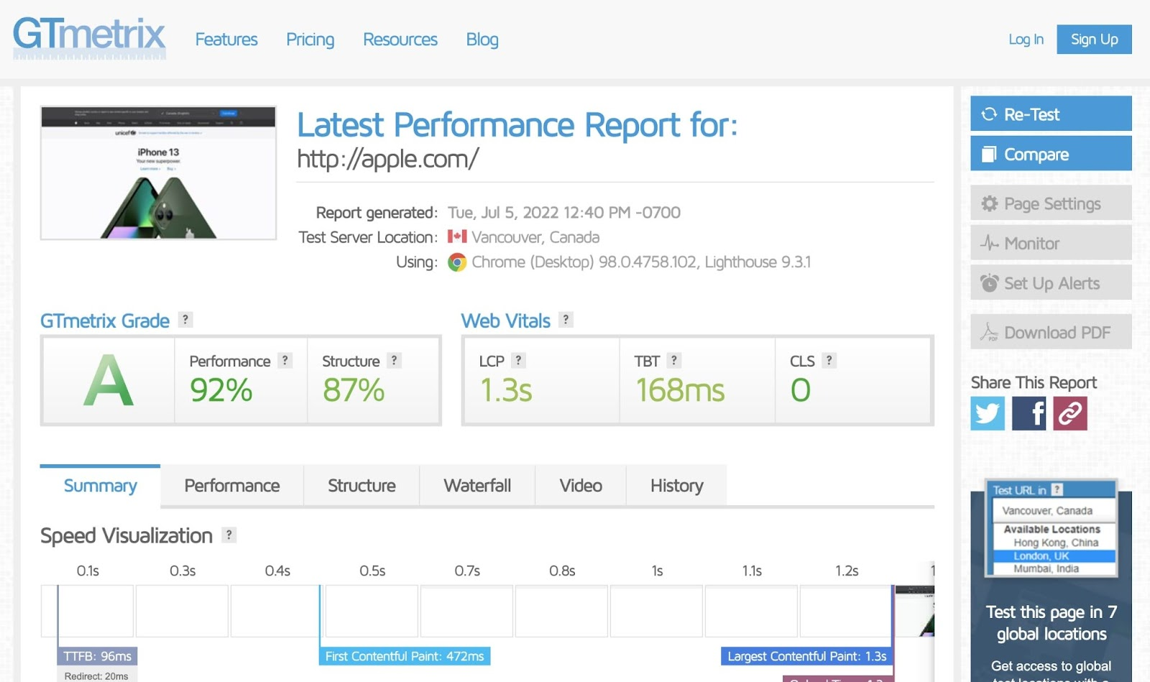

‍

GTmetrix is a trusted website monitoring tool with servers all around the world. When you enter your website into GTmetrix, you’ll get a full report and grade for the performance of your site.

You’ll be able to see your website’s full load time, top issues that need to be addressed, and what resources are consuming the most server load.

For example, GTmetrix might say that a top issue to fix on your website would be to avoid enormous network payloads, and it will give you a full list of URLs on your website that need to be fixed.

Just like PageSpeed Insights, GTmetrix will also show if you’re passing or failing Google’s Web Core Vitals. What sets GTmetrix apart is that it lets you test your website from different device and browser combinations. However, you will need to create a free account to get access to those features.

3. [Pingdom](https://tools.pingdom.com/)

**Best for:** Continuous performance monitoring

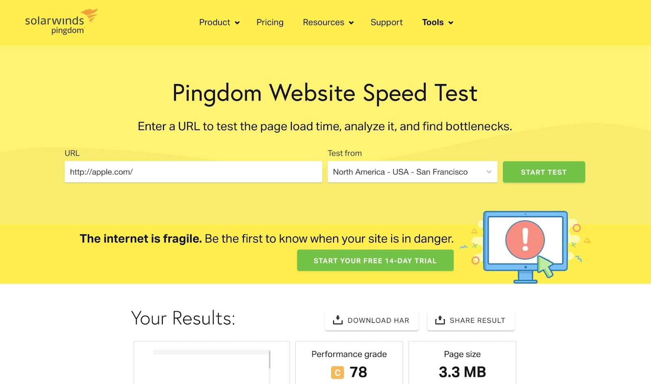

‍

Pingdom offers a full suite of different website monitoring tools. Their most popular is their Website Speed Test tool. However, they also have an uptime monitoring tool and an application monitoring tool.

The cool thing about Pingdom’s Website Speed Test tool is that it lets you monitor your website from different parts of the world. For example, you could test how your website performs for someone in both San Francisco, California and São Paulo, Brazil.

When you enter your website into Pingdom, it will look up information about your DNS, hosting, and web server. You’ll get a website grade, along with a score from 0-100, that indicates where your website stands compared to others on the web.

Just like the previous tools mentioned, Pingdom will give you actionable insights on what you can improve on your website. You’ll be able to see things like unnecessary redirects, the number of HTTP requests, and images that need to be compressed.

You’ll also be able to see a breakdown by percentages of what elements on your site take up most of its loading time.

Pingdom is a great tool to use, in combination with other tools on this list, to get deeper insights on what you can improve on your site. They also have a paid service that constantly monitors your website whenever it’s in danger.

4. [WebPageTest](https://www.webpagetest.org/" \t "_blank)

**Best for:** A comprehensive performance test

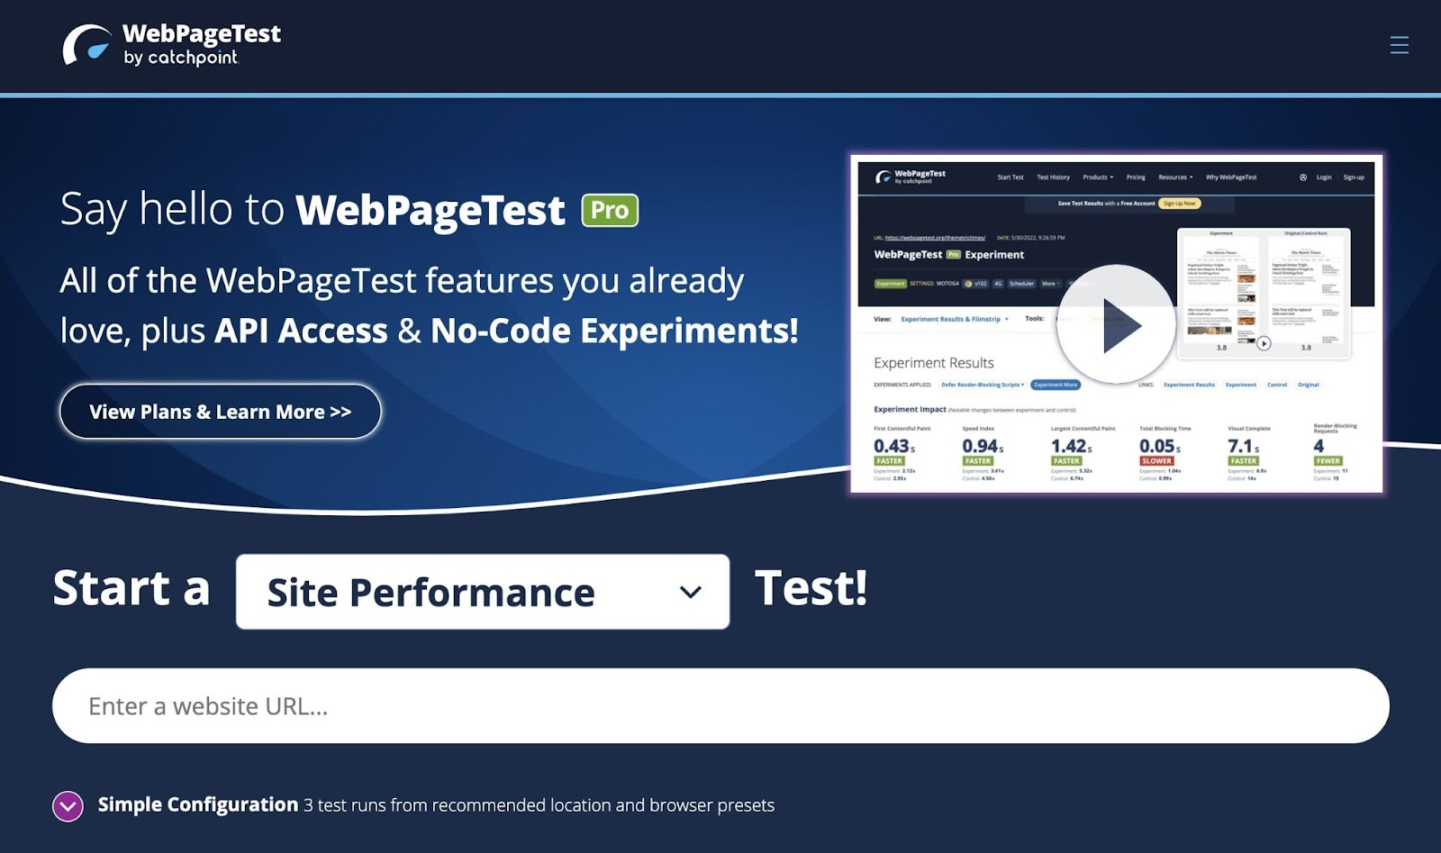

‍

WebPageTest is a free and open-source website performance test tool that lets you monitor everything about your site — from site performance, Lighthouse scores, Web Core Vitals, visual comparison, and traceroute.

You also have the option to check your website from either mobile or desktop and from different locations around the world.

Lots of websites are constantly being monitored with WebPageTest, so it will take a while for your full report to be generated with this tool. However, once you do have your full performance report, you’ll be able to see things like a content breakdown, how many requests are being made on a given page, and what improvements need to be made.

You can also run multiple tests on your site and the tool will show the median results of all of your tests. This is a great way to truly see what’s going on with your site as many performance testing tools will show different results each time you run a test.

5. [WAVE Web Accessibility Evaluation Tool](https://wave.webaim.org/)

**Best for:** Checking for web accessibility errors

‍



Anyone can view your website, so it’s important to make sure that it’s accessible to everyone. WAVE Web Accessibility Evaluation Tool lets you make your website content more accessible to individuals with disabilities.

If you’re using Webflow to build your website, you’ll already have access to [these tools](https://webflow.com/accessibility) when designing. However, it’s still a good practice to check your website for web accessibility.

When you enter your website into this tool, you’ll get a full report on things like contrast errors, structural elements in your design, and where you’re missing ALT text.

While this tool is not so much a performance tool, it’s an important one to run your website through. Improving accessibility on your site can help with user experience, which can help in your ability to rank in search engines and to build trust with your visitors.

WAVE Web Accessibility Evaluation Tool is free to use and one I highly recommend everyone run their websites through because a more accessible web makes for a better web.

6. [SEO Site Checkup](https://seositecheckup.com/)

**Best for:** Checking for SEO errors

‍

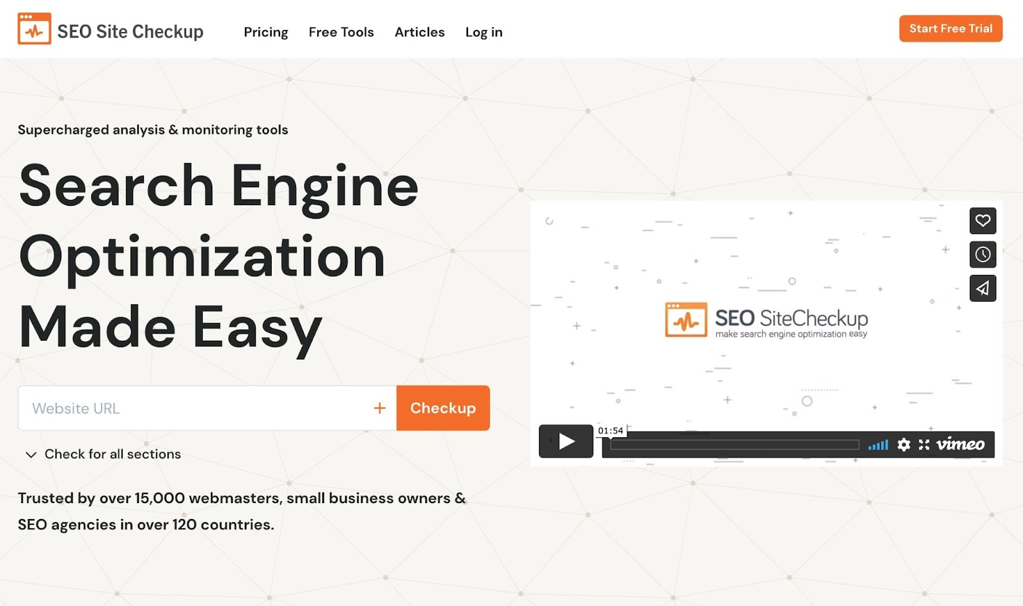

‍

If you’re serious about SEO and driving people to your website organically, SEO Site Checkup is a tool you need to check out.

Trusted by over 15,000 SEO professionals, SEO Site Checkup monitors your website for common SEO issues. Once you enter your website, you’ll get an SEO grade from 0-100, along with actionable insights on what needs to be fixed.

The tool will give you a full list of recommendations for things like your meta title, meta description, social media meta tags, [PASF keyword](https://www.marketermilk.com/blog/people-also-search-for) usage, and what your site looks like in Google’s search results.

You’ll also be able to check your website’s responsiveness and see if it passes security standards using an SSL and HTTPS on your domain.

Again, if you’re building and hosting your website on Webflow, you’ll pass all the security standards. And you’ll also have access to all the [SEO tools needed](https://webflow.com/seo) to execute on the recommendations provided by SEO Site Checkup.

7. [Uptrends](https://www.uptrends.com/tools/website-speed-test)

**Best for:** Checking page speeds from different browsers

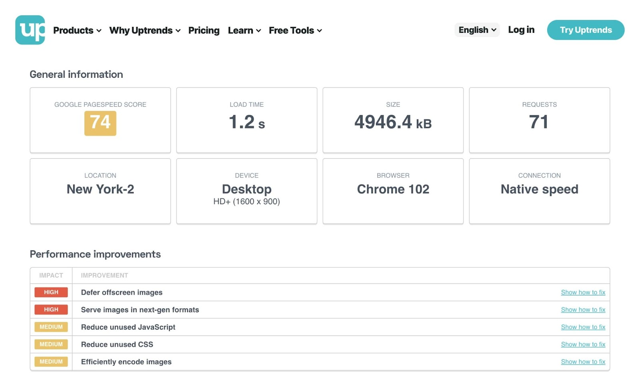

‍

Last on the list is Uptrends. This website performance test tool offers a full suite of tools — from website speed tests, uptime tests, user experience tests, and cloud-based server and network monitoring.

Uptrends gives you the option to check your website’s speed from different server locations in the world, different device types, and different browsers — giving you a comprehensive test across multiple different ways someone may view your website.

The tool pulls data from Google’s PageSpeed Insights and gives you actionable insights on what performance improvements you can make on your site. When you enter your website into Uptrends, you’ll also be able to view its request waterfall — an overview of what loads on your website in order.

This will allow you to see which parts of your website slow down its overall load time and how it impacts your Web Core Vitals and performance scores. You’ll also be able to compare page speed from different browsers such as Chrome, Internet Explorer, or Firefox.

Summary

The go-to website performance test that most people use would have to be Google’s PageSpeed Insights. However, GTmetrix and Pingdom are probably the two most sought after among those who are serious about monitoring all aspects of their website from different locations in the world.]

It’s important to run your website through multiple site performance testing tools because not every tool will show the exact same results.

Related polices and other relevant documents

Staff Code of Conduct

Related legislation

* [The Online Safety Act 2021 expands Australia’s protections against online harm, to keep pace with abusive behaviour and toxic content.](https://www.esafety.gov.au/newsroom/whats-on/online-safety-act#:~:text=The%20Online%20Safety%20Act%3A,services%20other%20than%20social%20media)
* [SOCI Act 2018 for data storage and processing](https://www.cisc.gov.au/information-for-your-industry/data-storage-and-processing/legislation-regulation-and-compliance/soci-act-2018)
* [Website development legal requirements](https://www.artslaw.com.au/information-sheet/website-development/)

Please also check out

* [Internet Regulation in Australia](https://humanrights.gov.au/our-work/publications/internet-regulation-australia)
* [ACCC Telecommunications and internet](https://www.accc.gov.au/by-industry/telecommunications-and-internet)

Review Date

June 2024

Contact Information

Chief Information Officer

Revision History

|  |  |  |  |  |
| --- | --- | --- | --- | --- |
| Version No. | Approved/ Amended/ Rescinded | Date | Approval Authority | Amendments |
| 1.0 | Approved | August 2023 | ITC MD |  |
| 1.1 | Amended | January 2024 |  | Corrected grammar errors |

<https://docs.ckan.org/en/2.9/contributing/html.html>